Lab1 – Mortgage Calculator Screenshots

Nexus 5 (Portrait Mode)
- Welcome Screen
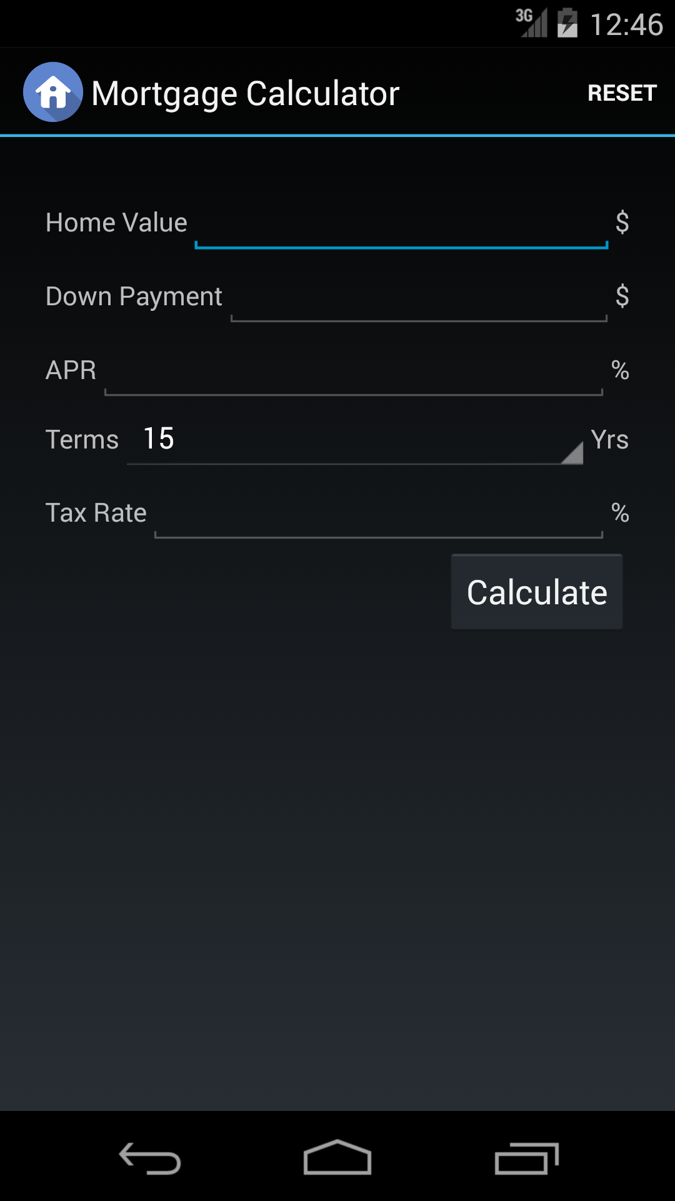

- Home Value Null Check
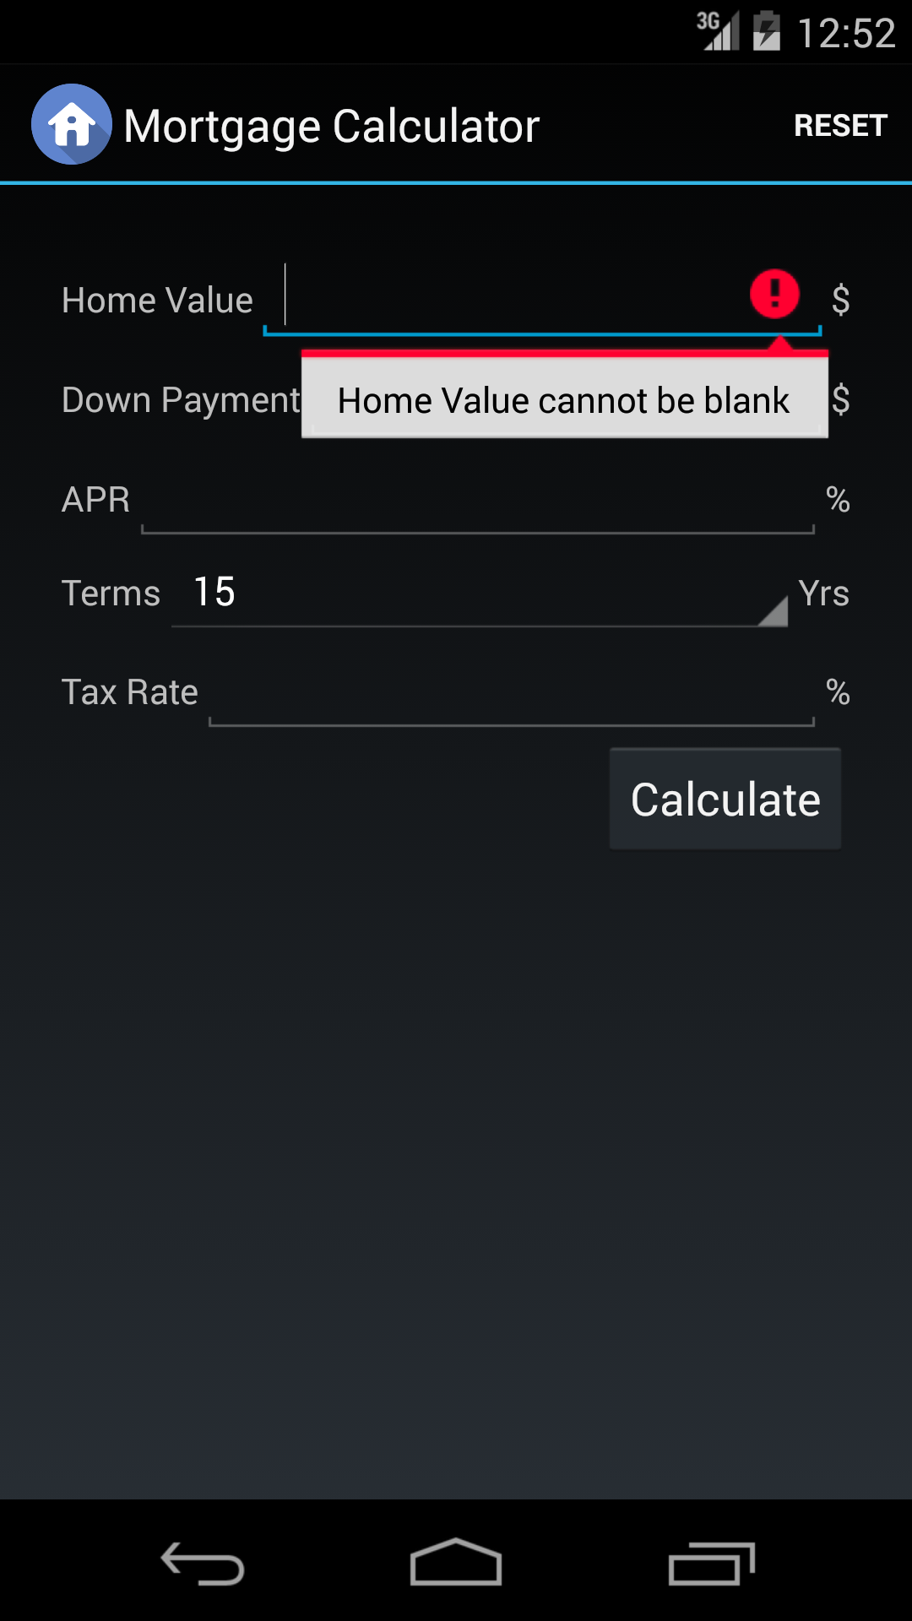

- Down Payment Null Check

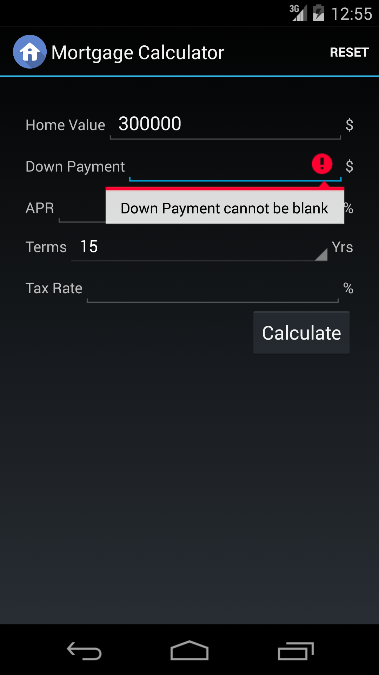

- APR Null Check
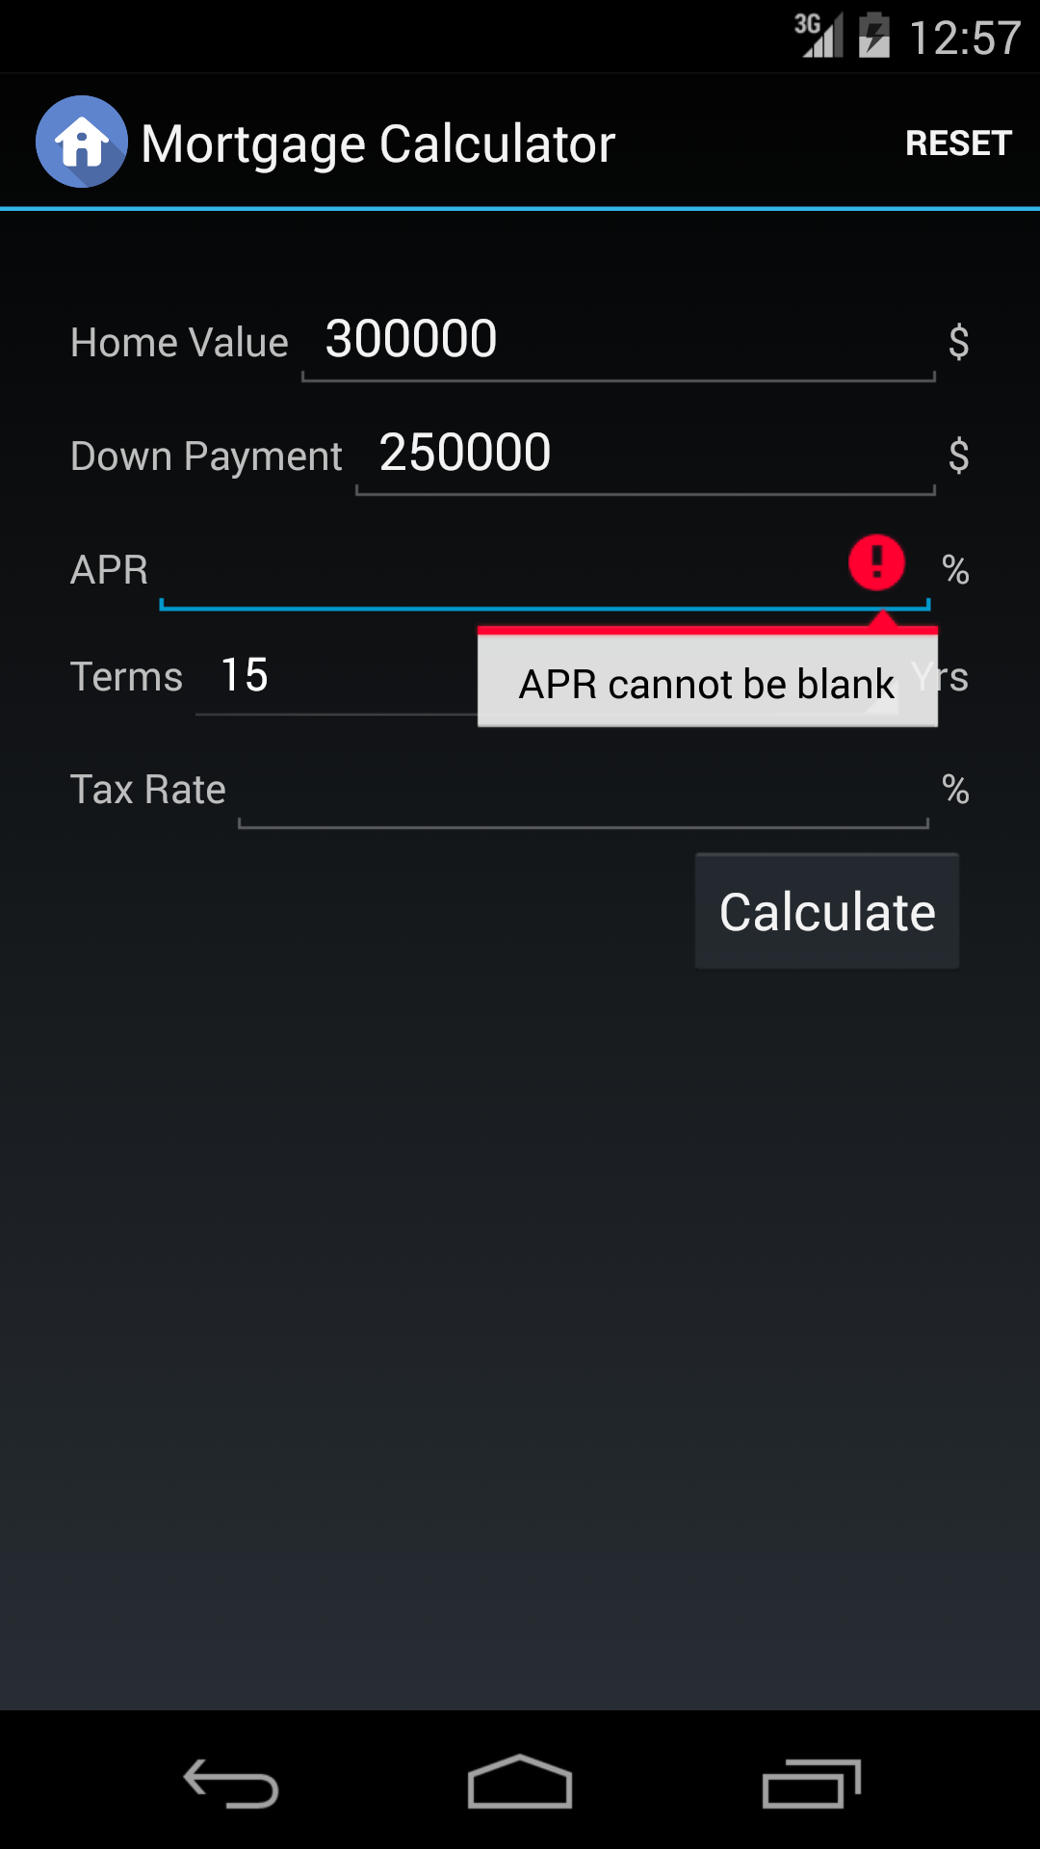
- Tax Rate Null Check

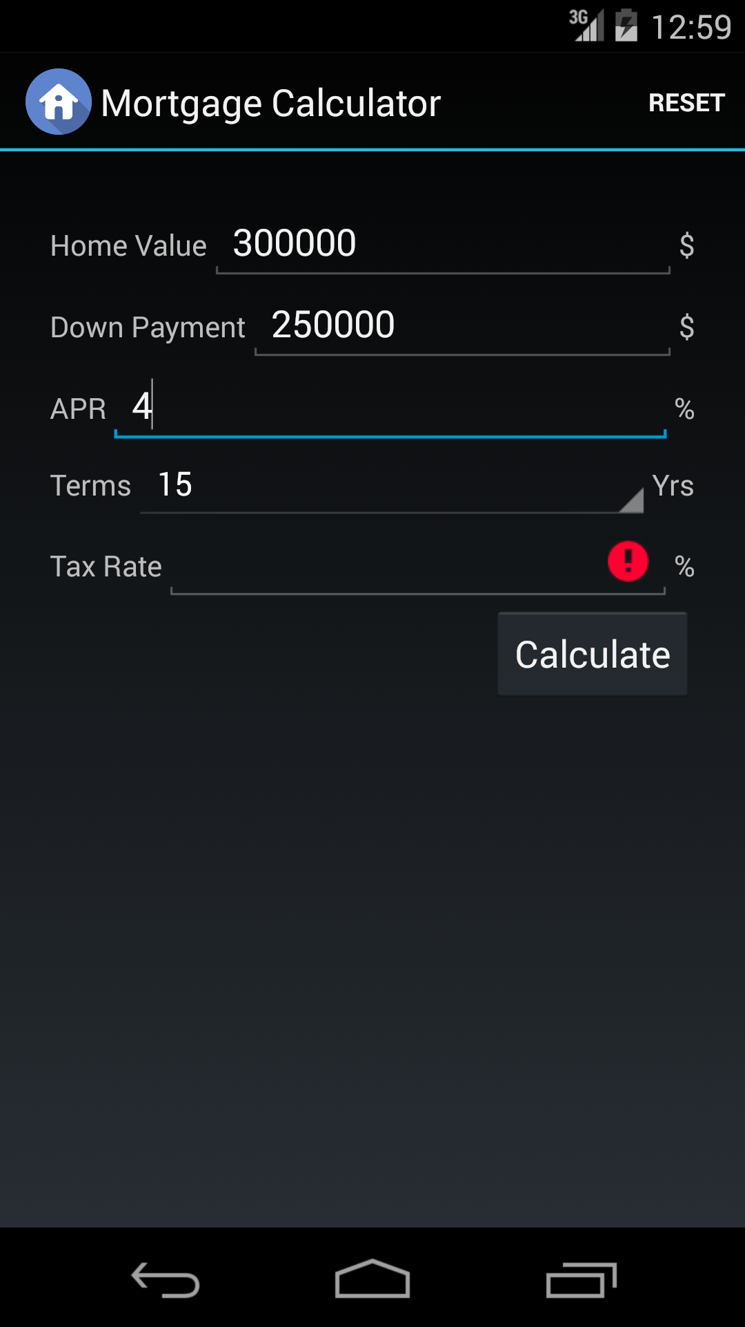

- Valid Inputs for all Fields
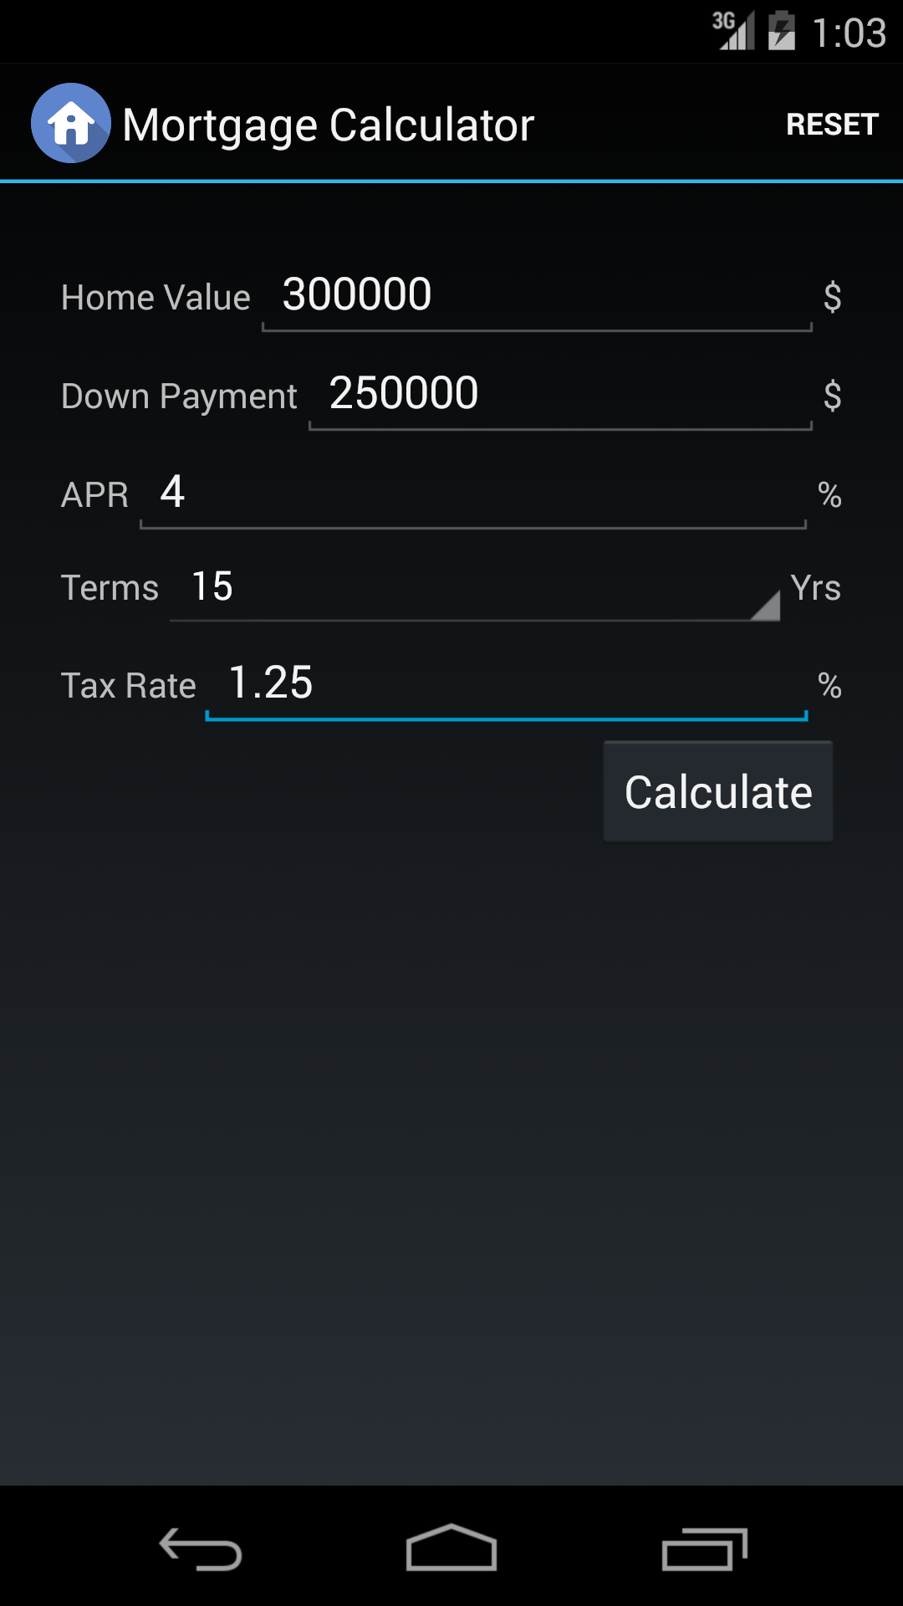
- On Click Calculate Button – Calculating Mortgage Values and displaying it in second fragment

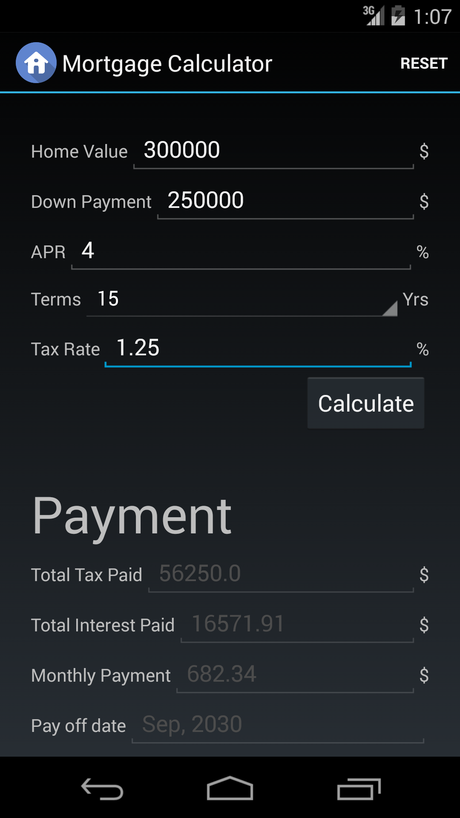
- Reset Button Display –

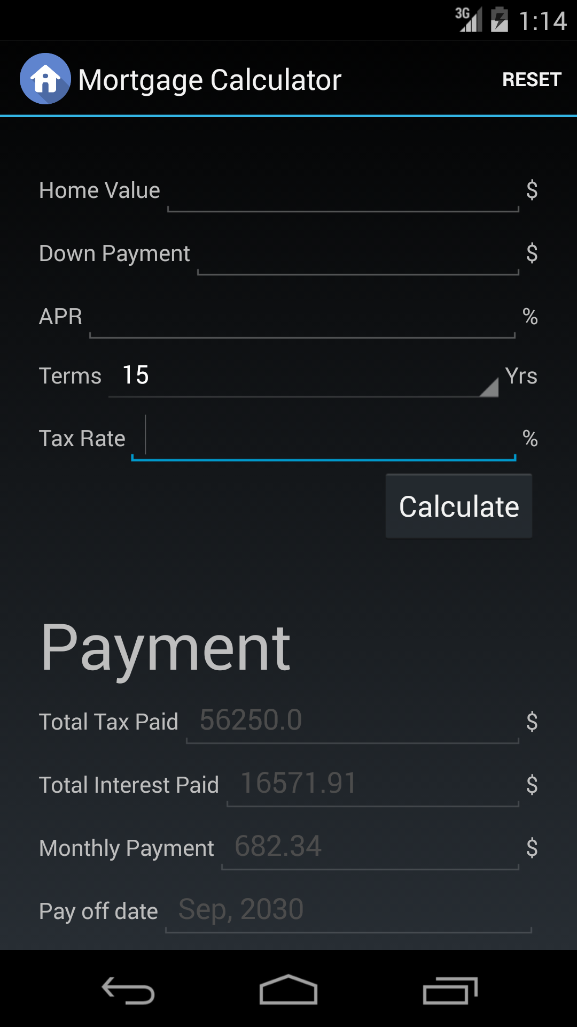
Nexus 5 (Landscape Mode)

- Valid Input in Landscape Mode
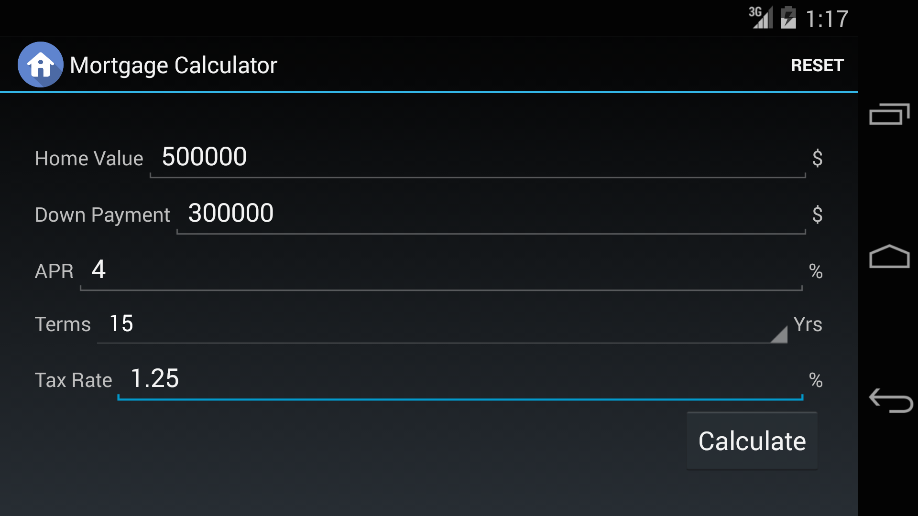

- Calculate Mortgage Values
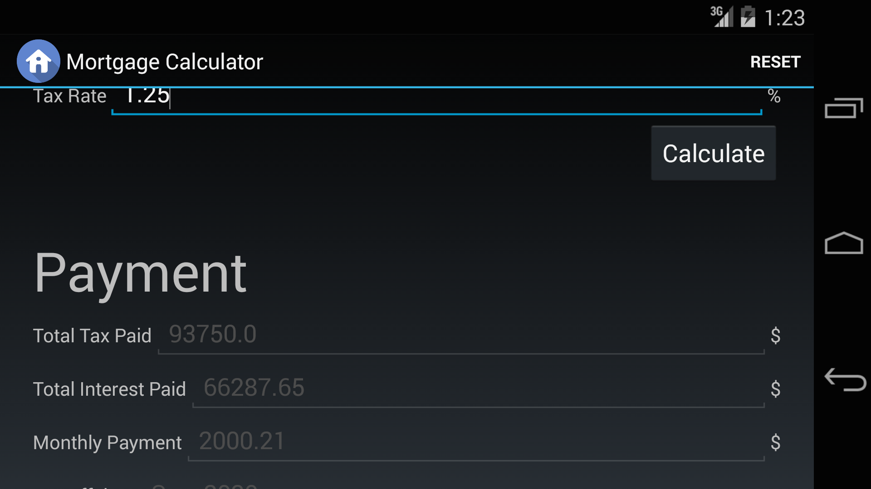

Bonus Point
Nexus 10 (Portrait Mode)

- Valid Input in Portrait Mode
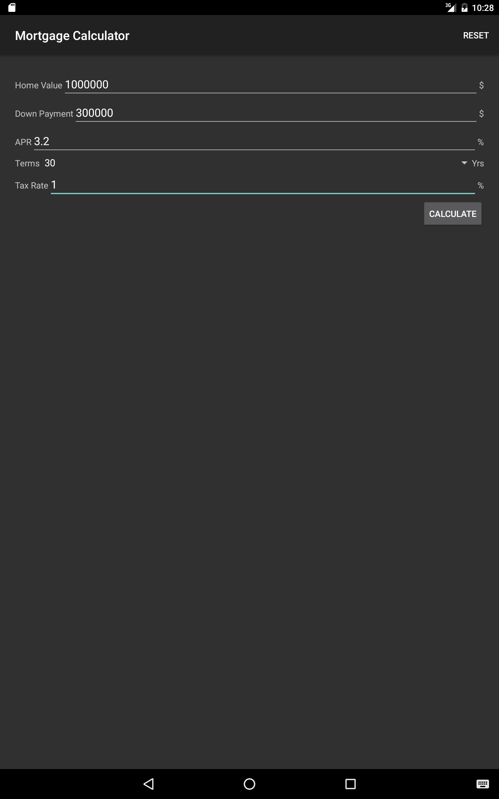
- Calculate Mortgage Values
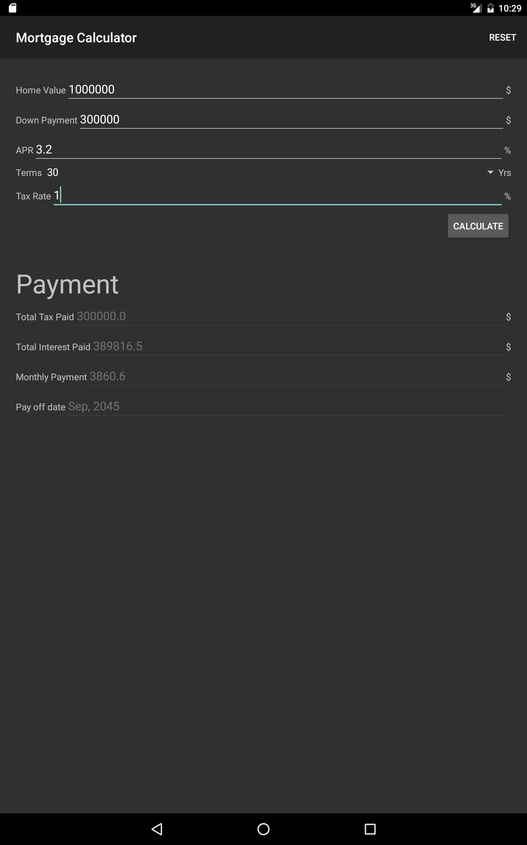
Nexus 10 (Landscape Mode)

- Valid Input in Landscape Mode
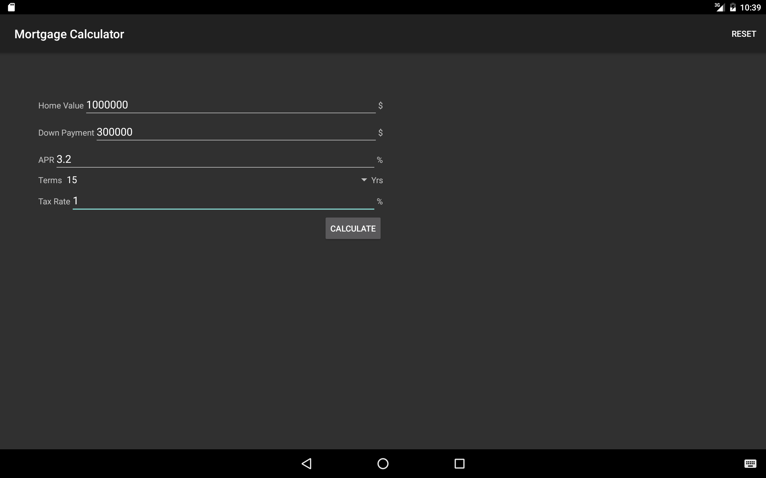

- Calculate Mortgage Values

